I think this is an excellent direction for Arz-e-Pak. Instead of being just another real estate listing portal, you could turn it into an AI-powered real estate and geospatial toolkit for Pakistan — a place where buyers, property dealers, architects, surveyors, developers, and investors can find properties and perform practical property-related tasks.
Your proposed tools fit particularly well with your existing City → Housing Scheme → Block/Area → Property hierarchy and GIS, AI search, memory, and RAG capabilities.
My recommendation is to create a dedicated “Tools & Utilities” section, with calculators, calendars, mapping tools, photo utilities, and document conversion grouped into separate categories.

1. The tools I would add
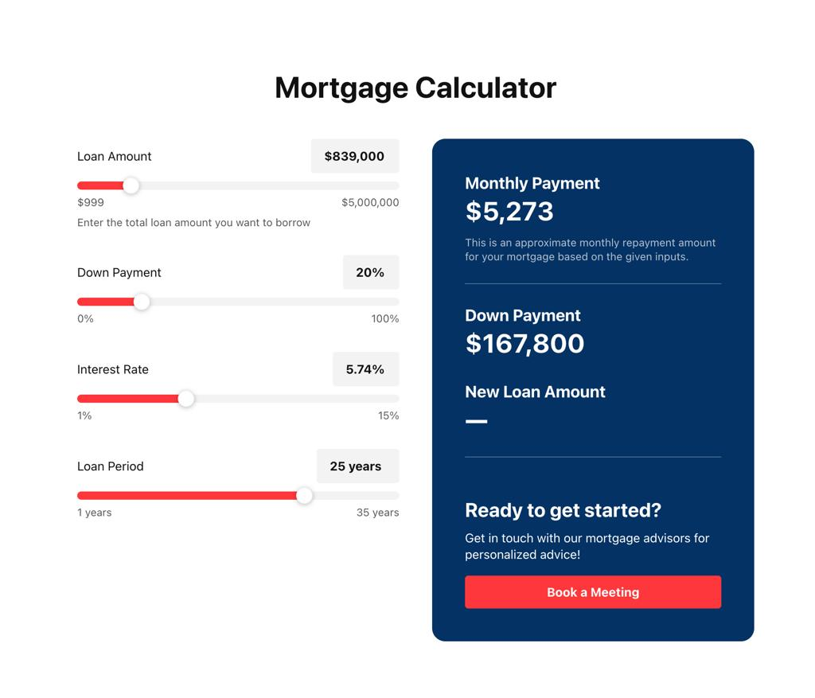

1. Real Estate Calculators
Build first
The easiest tools to launch, useful to buyers, sellers, dealers, and investors.
- Mortgage and home-financing calculator
- Monthly installment and down-payment calculator
- Rental yield and ROI calculator
- Property appreciation and investment growth
- Price per square foot, marla, and kanal converter
- Plot size and area converter
- Construction cost estimator
- Property transfer, stamp duty, and registration fee estimator
- Agent commission and capital gains estimators
- Joint investment and profit-sharing calculator
Smart feature: Let the AI assistant populate a calculator directly from a property listing.
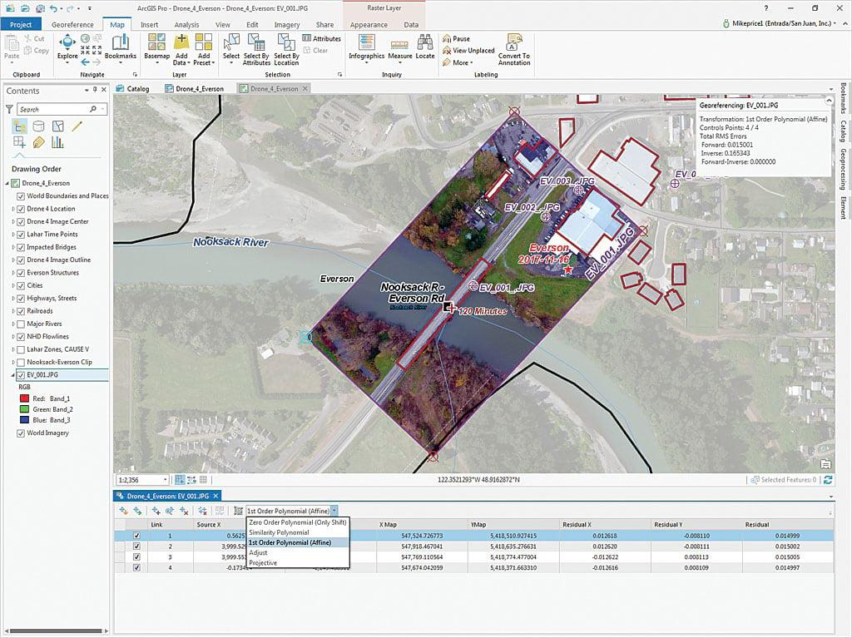

2. GIS, Georeferencing & Map Tools
Major differentiator
This could become one of Arz-e-Pak's strongest professional features.
- Georeference scanned maps, society plans, and plot layouts
- Align an image or PDF plan with real-world coordinates
- Place control points on known map locations
- Select coordinate reference systems (CRS)
- Overlay plans on satellite or aerial imagery
- Measure distance, perimeter, and area
- Calculate plot area from polygon coordinates
- Compare older and newer aerial images
- Import/export GeoJSON, KML, GeoTIFF, and supported GIS formats
- Locate properties and nearby amenities
Smart feature: Upload a scanned housing-scheme plan, align it to the real map, and explore its blocks and plots.


3. CAD, Plan & Drawing Utilities
Useful for architects, surveyors, developers, and housing societies.
- Preview DWG, DXF, and DGN drawings
- Convert supported CAD files to PDF, SVG, or images
- Extract drawing layers and metadata where supported
- Generate plan thumbnails
- Measure drawing dimensions when scale is known
- Compare two revisions of a site plan
- Overlay CAD drawings on GIS maps
- Create printable plot-layout sheets
Important: DWG and DGN are specialized formats. Full compatibility may require licensed conversion software or a dedicated processing service. PDF/image conversion alone will not preserve editable CAD layers.
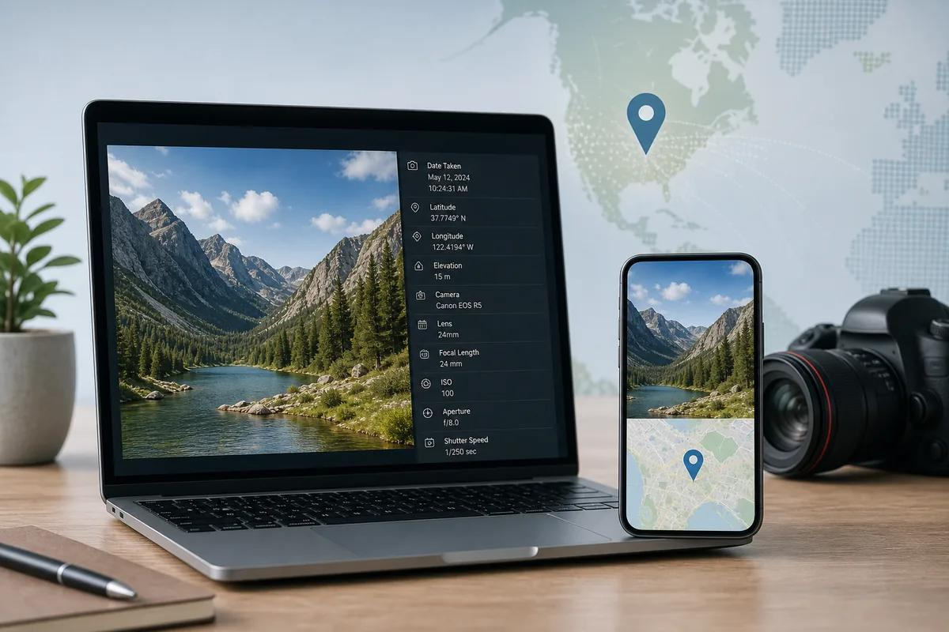

4. Photo Location & Geotagging
A particularly useful tool for property agents and field surveyors.
- Embed GPS coordinates into photo EXIF metadata
- Read existing photo GPS coordinates
- Display the photo location on a map
- Batch-geotag property photos
- Add a map pin to a property photograph
- Generate location-stamped survey photos
- Organize photos by city, scheme, block, and property
- Create a property photo report with a map and timestamp
Smart feature: Upload several site photos and associate each with a specific property record.
Privacy safeguard: make location embedding optional and warn users before sharing precise residential coordinates.
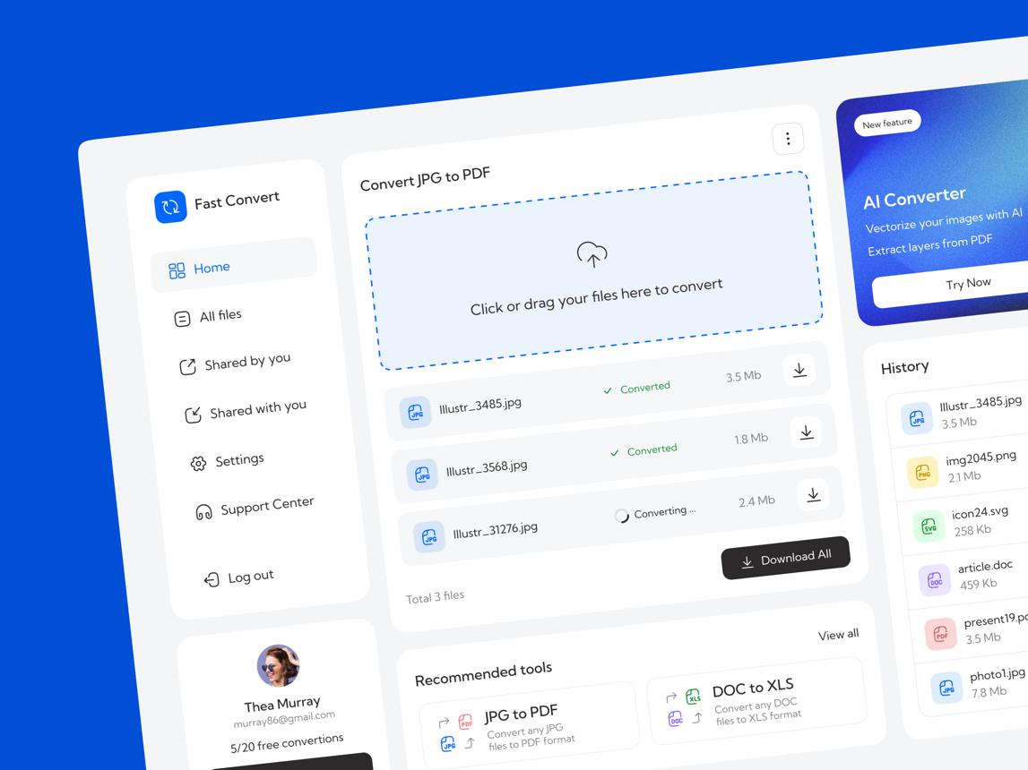

5. Document & File Conversion
Build first
A useful everyday utility suite for property documents.
- PDF to JPG, PNG, or WebP
- Images to PDF
- Word documents to PDF
- PDF merge, split, rotate, and compress
- PDF page extraction and reordering
- OCR for scanned property documents
- Extract tables and text from supported documents
- Batch image resizing and compression
- Generate PDF property brochures
- Convert supported map plans into downloadable images
Smart feature: Turn a property listing, photos, location map, and specifications into a branded PDF brochure.
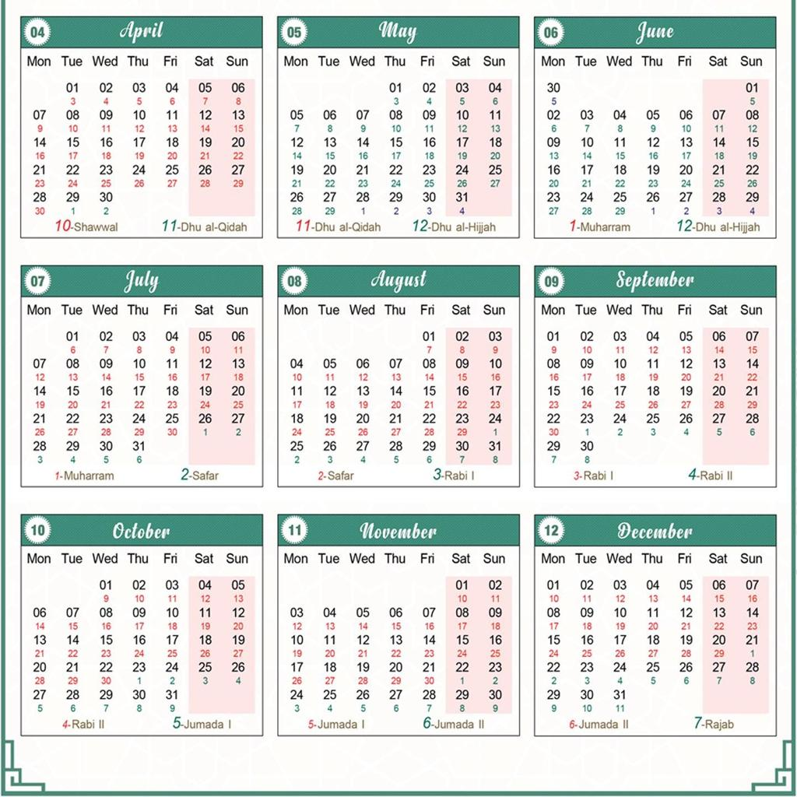

6. Pakistan & Islamic Calendar
Make this more useful than a basic calendar by connecting it to property workflows.
- Gregorian and Hijri date conversion
- Ramadan, Eid-ul-Fitr, Eid-ul-Adha, and other Islamic occasions
- Pakistan public holidays and regional holidays
- Property possession and handover dates
- Installment due dates and payment reminders
- Booking, inspection, and agreement expiry reminders
- Construction and project milestone calendars
- Downloadable calendar events
Islamic holiday dates can depend on moon sighting, so distinguish officially announced dates from predicted dates. Public holidays should be updated from authoritative Pakistani announcements.

2. Other tools worth adding
These could make the platform even more distinctive.
Plot & Construction Studio
Convert marla, kanal, square feet, square yards, and square metres; calculate dimensions and plot area; estimate material quantities; and produce basic printable plot diagrams. Allow different marla standards where applicable.
Property Document AI
Extract key fields from uploaded allotment letters, sale deeds, lease agreements, and approved plans. Flag missing fields and summarize clauses for review. It must not claim to authenticate ownership or replace a lawyer's title verification.
Satellite & Aerial Image Explorer
Compare dated imagery, view site boundaries, track visible construction progress, and overlay approved plans. Use imagery with appropriate licensing and display acquisition dates and resolution. Satellite imagery cannot by itself establish legal boundaries or ownership.
Reports & Export Studio
Generate property comparison reports, investment summaries, plot inventory reports, map PDFs, Excel exports, and branded presentations for agents and developers.

3. What the Tools Center could look like
I would design it as a modern dashboard with searchable tool cards, category filters, and a recent-tools section.

Arz-e-Pak Tools
Everything you need to calculate, map, convert and manage property.
BROWSE CATEGORIES
All ToolsCalculatorsGIS & MapsCAD & PlansPhoto ToolsDocumentsCalendar
Mortgage CalculatorEstimate monthly payments and total financing costExplore tool
Rental Yield CalculatorEstimate gross and net rental returnsExplore tool
Plot Area ConverterConvert marla, kanal, square feet and moreExplore tool
Georeference a PlanAlign a scanned plan to geographic coordinatesExplore tool
Map MeasurementMeasure land area, perimeter and distanceExplore tool
CAD Drawing ConverterPreview and convert supported CAD formatsExplore tool
Photo GeotaggerRead, add or view photo GPS coordinatesExplore tool
PDF & Image ConverterConvert, merge, split and compress documentsExplore tool
Pakistan Holiday CalendarBrowse public holidays and Islamic occasionsExplore tool
Property Brochure MakerCreate a shareable PDF from listing detailsExplore tool
Concept preview. Select any tool card to explore its implementation; these tools are not yet connected to your backend.

4. How I would prioritize development
Don't build every tool at once. Start with features that are relatively easy to deliver, then build the more technically demanding GIS and CAD workflows.
Phase 1 — Launch the Tools Center
Quick wins
- Unit and plot-area converters
- Mortgage, installment and rental-yield calculators
- PDF/image conversion
- Pakistan holiday calendar
- Property brochure generator
Phase 2 — GIS Workspace
- Georeferencing scanned plans
- GPS photo tagging
- Plot measurements and map overlays
- GeoJSON/KML/GeoTIFF import and export
- Aerial imagery comparison
Phase 3 — AI & Professional Tools
- AI-assisted property document extraction
- CAD drawing preview and conversion
- Automated plan-to-map workflows
- Market intelligence and investment reports
- Personalized tools and saved projects

5. Suggested technical architecture
Since your existing backend uses MCP and has GIS, memory, and RAG functionality, keep the tools modular rather than placing all their logic in server.py.
Component | Suggested technology
Web interface | Your existing frontend, with responsive tool pages
REST API | FastAPI with your existing MCP server integrated separately
Geospatial processing | GeoPandas, Shapely, Rasterio, GDAL/PROJ
Interactive maps | Leaflet or MapLibre GL JS
PDF and images | PyMuPDF, Pillow, and appropriate document converters
OCR | Tesseract or a suitable document AI service
CAD/DWG/DGN | Format-specific libraries or licensed conversion services
Calendar | Holiday data service or maintained official calendar dataset
Background processing | Task queue for large conversions and GIS jobs
File storage | Private object storage with expiring download links
Treat uploaded CAD drawings, PDFs, and photos as untrusted files: validate file types, limit file size, isolate conversion processes, and automatically expire temporary uploads.
My strongest recommendation: make Arz-e-Pak a combination of a property marketplace, a GIS workspace, and a real estate utility center. Start with calculators and document tools, then develop georeferencing and CAD capabilities as your professional differentiator. Your existing MCP/GIS architecture gives you a useful starting point for connecting these tools to the property data.

